**Project Documentation**

**COOKBOOK : Your Virtual Kitchen Assistant**

**1. Introduction**

* **Project Title:** COOKBOOK : Your Virtual Kitchen Assistant
* **Team ID :** NM2025TMID38443
* **Team Leader:** Nisha S

**Email :** sureshnisha2821@gmail.com

* **Team Members:**

Mohanapriya Y

**Email :** **Rajimona13@gmail.com**

Muskan J

**Email : Muskan99865@gmail.com**  Nandhitha S

**Email :** **Nandhithaskpc2024@gmail.com**

# 2. Project Overview

* **Purpose:** To simplify everyday cooking by offering users an easy, organized way to discover, follow, and enjoy recipes tailored to their lifestyle and preferences.To assist users at every step of the cooking journey from meal planning and grocery shopping to hands-free cooking instructions in the kitchen.To personalize the cooking experience by adapting to dietary needs, ingredient availability, cooking skills, and favorite cuisines.To reduce food waste and save time by helping users track pantry items, suggest recipes based on what they already have, and recommend smart substitutions.To make cooking accessible and enjoyable for everyone — whether a beginner, busy parent, student, or health-conscious eater — through a friendly, intuitive virtual assistant.

* **Features:**

* 1. Smart Recipe Discovery
  2. Personalized Meal Planning
  3. Pantry & Ingredient Management
  4. Hands-Free, Step-by-Step Cooking Instructions
  5. Nutritional Information & Allergen Alerts
  6. AI Powered Substitutions & Cooking Tips

# 1.Smart Recipe Discovery

* Suggests recipes based on ingredients you already have
* Filters by cuisine, dietary preferences (vegan, keto, gluten-free), cooking time, and skill level

# 2.Personalized Meal Planning

* Weekly or monthly meal planning tailored to your goals (e.g., weight loss, family-friendly, quick meals)
* Auto-generates shopping lists from selected recipes

# 3.Pantry & Ingredient Management

* Track what's in your pantry
* Get notified when ingredients are running low
* Suggest recipes to use up soon-to-expire items

# 4.Hands-Free, Step-by-Step Cooking Instructions

* Voice-guided cooking mode to keep your hands free while cooking
* Built-in timers and progress tracking for each recipe step

# 5.Nutritional Information & Allergen Alerts

* View calories, macronutrients, and dietary tags
* Highlight allergens or ingredients to avoid based on user profile

# 6.AI Powered Substitutions &Cooking Tips

* Suggests ingredient substitutions in real time
* Offers cooking hacks and tips for better results

# 3. Architecture

* **Frontend:** React.js with Bootstrap and Material UI — provides a responsive and interactive UI for recipe browsing, meal planning, pantry management, and shopping list generation.
* **Backend:** Node.js and Express.js — handles server-side logic, API endpoints, user authentication, recipe management, and meal plan generation.
* **Database:** MongoDB — stores user profiles, recipes, pantry items, meal plans, shopping lists, and chat messages with flexible document structure.

# 4. Setup Instructions

* **Prerequisites:**
* Node.js
* MongoDB
* Git
* React.js
* Express.js **–** Mongoose **–** Visual Studio Code
* **Installation Steps:**

# Clone the repository git clone

# Install client dependencies cd client npm install

# Install server dependencies cd

../server npm install

# 5. Folder Structure

RECIPIE/

├── node_modules/

├── public/

├── src/

│ ├── components/

│ │ ├── About.jsx

│ │ ├── CategoriesHome.jsx

│ │ ├── Footer.jsx

│ │ ├── Hero.jsx

│ │ ├── Navbar.jsx

│ │ ├── NewsLetter.jsx

│ ├── images/

│ ├── pages/

│ │ ├── Category.jsx

│ │ ├── Home.jsx

│ │ ├── Recipie.jsx

│ ├── styles/

│ │ ├── About.css

│ │ ├── CategoriesHome.css

│ │ ├── CategoryPage.css

│ │ ├── Footer.css

│ │ ├── Hero.css

│ │ ├── Home.css

│ │ ├── Navbar.css

│ │ ├── NewsLetter.css

│ │ ├── Recipie.css

│ ├── App.css

│ ├── App.js

│ ├── App.test.js

│ ├── index.css

│ ├── index.js

│ ├── logo.svg

│ ├── reportWebVitals.js

│ ├── setupTests.js

├── .gitignore

├── package-lock.json

├── package.json

└── README.md

# 6. Running the Application

* **Frontend:**
  1. client

npm start

* **Backend:**
  1. server npm start
* **Access:** Visit http://localhost:3000

**7. API Documentation User:**

* /api/user/register – Register
* /api/user/login – Login **Categories:**
* /api/categories – Get all categories
* /api/categories/:id – Get single category
* /api/categories/create – Create category **Recipe:**
* /api/recipes – Get all recipes
* /api/recipes/:id – Get single recipe
* /api/recipes/create – Create recipe

# 8. Authentication

* JWT-based authentication for secure login and registration
* Middleware protects private routes (e.g., creating, updating, deleting recipes)
* Role-based access control for admin and regular users
* Passwords securely hashed before storage
* Token expiration and refresh mechanism for enhanced security

# 9. User Interface

1. **Homepage**

* Search bar to find recipes
* Featured recipes shown as cards with images
* Easy menu to access categories and saved recipes

2. **Recipe Page**

* Recipe photo at top
* Ingredients and step-by-step instructions below
* Buttons to save or share the recipe

3. **User Profile**

* List of saved and created recipes
* Option to add new recipes with a simple form

4. **Categories Page**

• List of recipe categories to browse

5. **Responsive Design**

• Works well on phones, tablets, and desktop

# 10. Testing

* **Manual Testing during milestones**

Test each feature thoroughly after development milestones to ensure functionality and usability.

* **Tools Used:**
* **Postman:** For testing all API endpoints (user auth, recipes, categories, comments).
* **Chrome Dev Tools:** For debugging UI, checking responsiveness, and performance testing.
* **Key Testing Areas:**
* User registration and login workflows
* Recipe creation, editing, deletion
* Category browsing and filtering
* Saving and sharing recipes
* Responsive UI on different devices

# 11. Screenshots or Demo

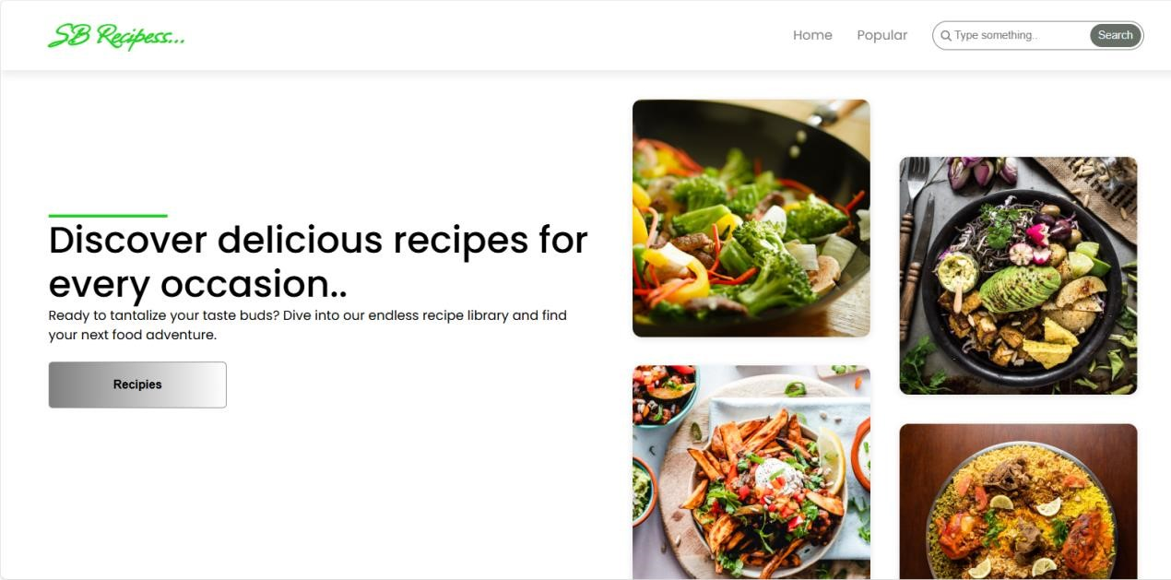

# Fig 1 : Home Page

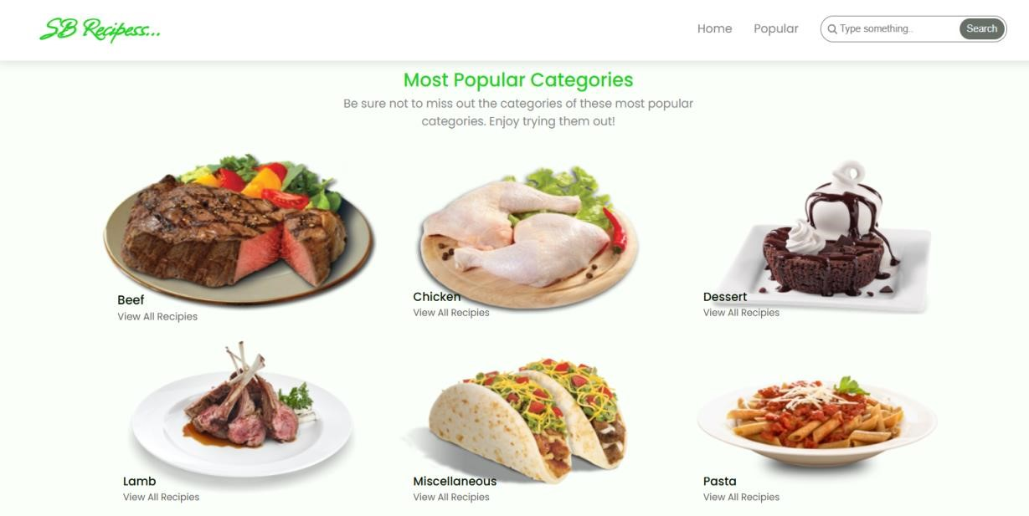

# Fig 2 : popular category page

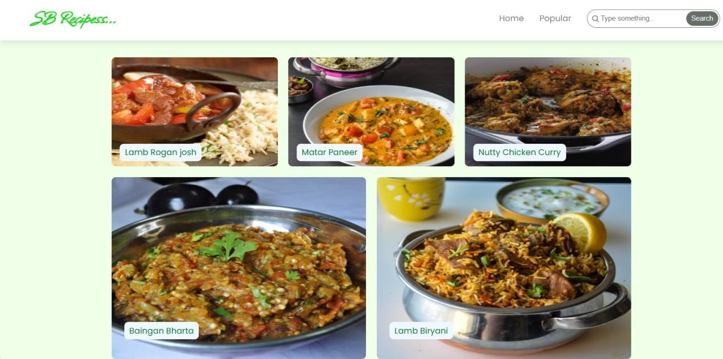

# Fig 3 : Trending dishes page

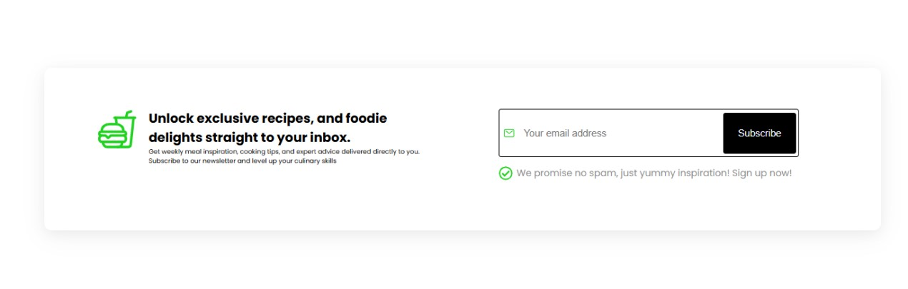

# Fig 4 : News Letter page

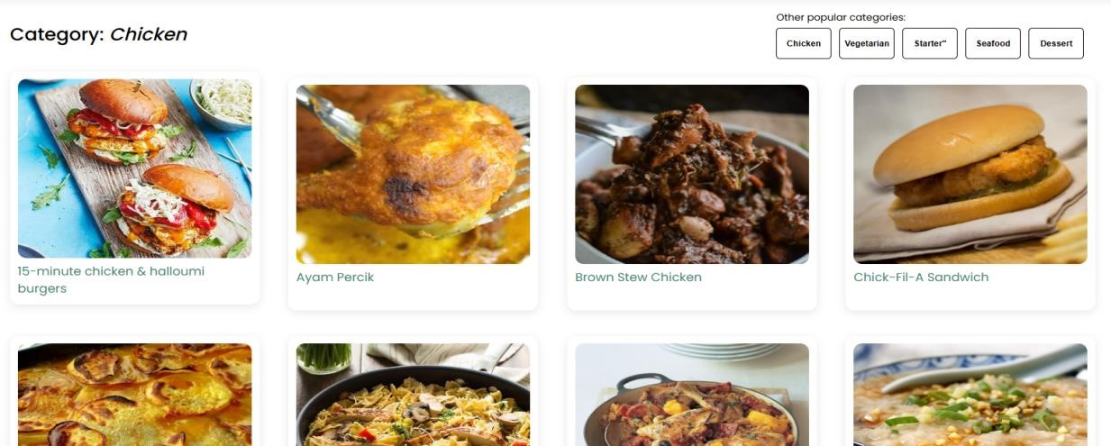

# Fig 5 : Category dishes page



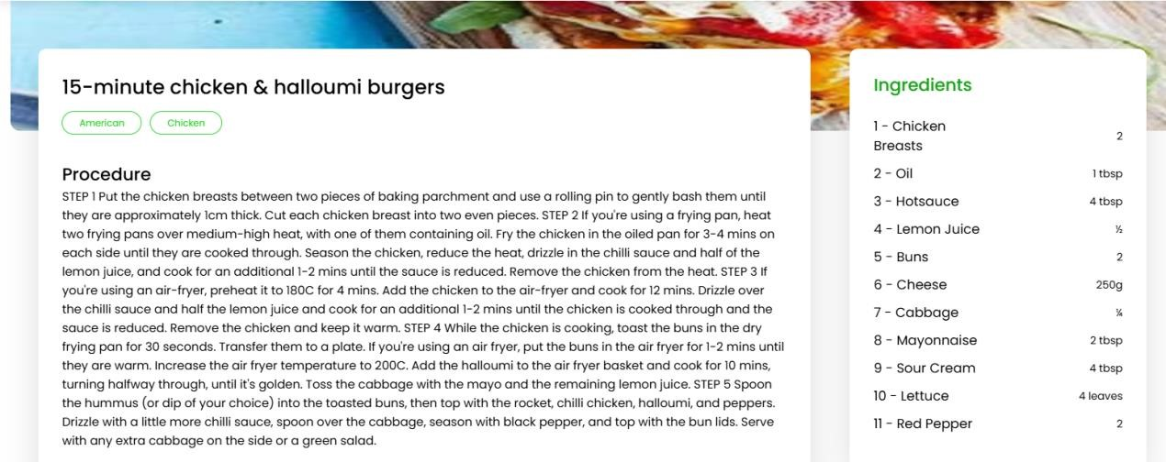

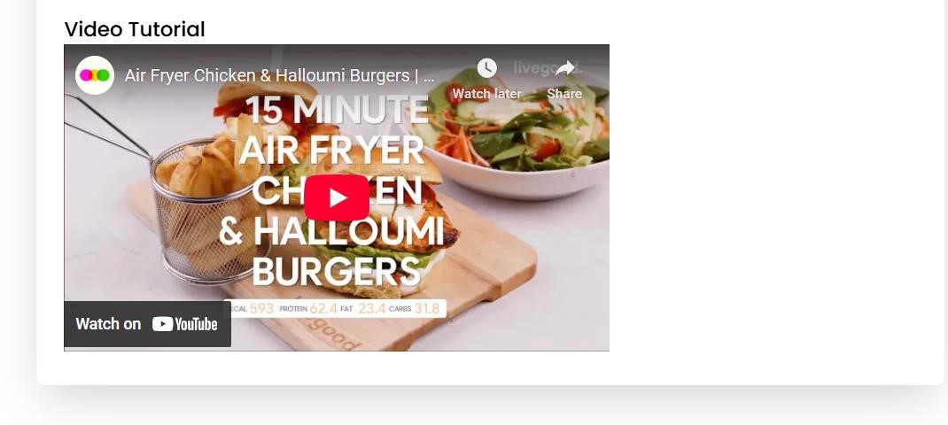

**Fig 6,7,8 : Recipe page**

# 12. Known Issues

* **Image Upload Limitations :**

Large image files may cause slow uploads or failures.

* **Search Function :**

Search results might sometimes be incomplete or slow with large datasets.

* **Recipe Editing :**

Unsaved changes can be lost if the user navigates away without confirmation.

* **User Authentication :**

Token expiration might log users out unexpectedly without clear notification.

* **Responsive Design :**

Some UI elements may not display perfectly on very small screen sizes or older browsers.

* **API Rate Limiting :**

No current throttling on API calls, which may cause performance issues under heavy use.

* **Comment Moderation :**

Lack of automated filtering for inappropriate content in comments.

# 13. Future Enhancement

* **User Profiles & Social Features :**

Enable users to follow each other, share recipes directly, and see activity feeds.

* **Recipe Ratings & Reviews :**

Allow users to rate recipes and leave detailed reviews to improve community engagement.

* **Advanced Search & Filters :**

Add ingredient-based search, dietary preferences (vegan, gluten-free), and cooking time filters.

* **Recipe Video Tutorials :**

Support uploading or embedding cooking videos alongside recipes.

* **Shopping List Generator :**

Automatically create shopping lists from saved recipes.

* **Meal Planning :**

Help users plan meals for the week with calendar integration.

* **Multi-language Support :**

Localize the platform for different languages and regions.

* **Push Notifications:**

Notify users about new recipes, comments, or activity on their posts.

* **Offline Access:**

Allow users to save recipes for offline viewing.

* **Automated Moderation:**

Use AI to filter inappropriate comments or spam.